**Some things to get you started**

**\*before seeing clients ensure you are fully orientated to the site\***

**(Ask your NIC or NPA if you need to block appointment times off for this)**

* Introduce yourself to the team/circle of care
  + Who are the other nurses, what skills are they coming with
  + Who is the NPA, HD, CHR, Patient Travel, First Responders
* Find your residence and get settled as you need.
  + Collect your residence key and clinic FOB- follow pharmacy guidelines for signing out
  + You are expected to be back at the clinic within 1 hour, or as directed by your team
  + Review your residence booklet for important information such as internet password, security, and local phone numbers
* Connect with team to discuss orientation needs, ensure you have time to complete your orientation without being asked to complete other tasks.
* Log onto a computer
  + If you do not have access please contact IMIT 1-855-913-2085 OPTION 2 IMMEDIATELY
  + Make sure you have access to your FNHA email, every nurse is assigned an email account including agency.
  + Ensure you have access to the [Nursing Stations and Health Centers Gathering Space](https://partners.fnha.ca/sites/NS/NSHC/Default.aspx)
  + If you have access issues not easily resolved with IT please reach out to the [ruralremote_practice@fnha.ca](mailto:ruralremote_practice@fnha.ca)
* Familiarize yourself with Nursing Station and Health Center Gathering Space page, it has lots of very helpful resources. See Organization Map at the end of this document.
* Have a read through of the Nursing Station’s Site Specific Orientation PowerPoint on Gathering Space.
  + Some clinics have an orientation binder, know where it is and reference it as needed
* Complete Clinic’s Seek and Find activity
* Find and Review the “Important Numbers” Poster
  + these posters should be posted around the clinic, in nursing offices and the ER
  + Ensure you understand consult process in your site
    - Calling RTVS/RuDi vs MRP
    - What is LOC and when should you call
* Narcotic count
  + Complete on arrival and when leaving

**Before you leave at the end of your first day:**

* Review Call Schedule with your team members
  + What phones are used, how do you set up the phones
  + How to call in your second, and when is that appropriate
  + Ensuring availability (not going for walks/gym/event without communicating this)
  + Is there first responders in community, how do people get to the clinic
  + Ask about site specific Medivac process
  + Medication deliveries or shipments after hours, how are these handled
* Review Do Not See Alone list
  + Check the clinic’s gathering space for an up to date copy of the list.
  + Any intoxicated person or suspected of being under the influence of any substance should not be seen alone after regular clinic hours. A second person could be a sober family member or a first responder
* Review Safety Considerations while in community
  + Ask team members (wildlife, dogs, security, police availability and contact)

**Within 1-2 days of arrival**

* Review handover notes
  + Ask team where these are kept (Gathering Space, binder or loose)
  + Hand over is important! Write one before you leave, and read them when you start your assignment
  + Review Challenges & Objectives in the Nurse Daily Log program
* With your local team, choose which programs or duties you will manage while in community
  + Immunization program, Well Woman program, Prenatal program, Chronic Disease
  + You do not need to have experience in these areas to manage the program, if no one else is able to manage the programs at minimum review them
  + Review clinic Objectives in the Daily Log program- take on anything that interest you or is priority, discuss with team

**Daily Clinic Routines**

* Start your day off with looking at the appointment book and the site calendar for anything happening that day/week (often located in the NIC office or with the NPA, but ask around if you can’t locate)
* Have a check in with your team, set priorities for the day
  + Who needs office/admin time
  + Any events happening- who is assigned to this (doctors day, school visits, etc)
  + Which programs are scheduled for the day
  + Any team member wanting to take on specific visits
  + Who will be reviewing labs/faxes
  + Any meetings occurring? Who will need to attend?
  + Do you need to adjust the appointment book to meet team needs?
* Check all temperature monitored fridges twice a day
  + log temps on the paper log
  + Fridges include immunizations, iSTAT materials, GenXpert materials
* Ensure you take your coffee breaks
  + Highly suggest getting fresh air in this time
  + All nurses are entitled to two 15 minute coffee breaks in a 7.5hr day, as well as your 1 hour lunch
  + If a nurses needs to stay over lunch with a client, ensure there is a plan to relieve them for their break (stager breaks)
  + Any issues with this, call your SCNA (on the important number poster)
* Clients will present for appointments or drop in throughout day.
  + Ensure patient load is equitable within the team
  + Revisit priorities as a team as needed
  + Ensure nurses, charting and Daily Log entries are caught up or manageable before accepting non-urgent drop-ins
* Check your FNHA email regularly!
  + Keep an eye out for reminders from SCNA and PC teams- There is also an update board located on the Nursing Station and Health Center Gathering Space for quick review of recent updates.
  + Check for meetings, webinars and training sessions available to you- the Nursing Station and Health Center Gathering Space has a calendar as well, for upcoming events like Nursing Station Calls and training.
* Check in PRN with the Health Director, CHR and Homecare nurse
  + Good communication is key!
  + Anything they need to be aware of? Elderly or complex medical patients
  + Anything you should be aware of? Community events or client concerns
* Familiarize yourself with the process of receiving shipments.
  + Prioritize this process in your day
  + Procedure located on Nursing Station and Health Center Gathering Space
* Familiarize yourself with the Narcotics and Controlled Substance Procedure.
  + All Controlled Substances require physician signature. No exceptions.
  + Refer to the Controlled Substances binder for how to use the form (Annex 9)
  + Any questions please ask the SCNAs or our pharmacist Twinkle
    - SCNAs – see important numbers poster
    - Twinkle Ruparel ( [twinkle.ruparel@fnha.ca](mailto:twinkle.ruparel@fnha.ca) )
  + Resources available on the Nursing Station and Health Center Gathering Space Page

**Weekly/Monthly Clinic Items**

* Work on month end tasks to give you plenty of time to complete by month end.
  + Due first week of the next month
  + Inventory for orders should start no later than the 20th of the month
  + Some items can take several months to ship, review previous months orders before completing a new request to avoid over ordering
  + Month End Checklist available on the Nursing Station and Health Center Gathering Space Page along with instructions on how to complete
* Various Checks are required to keep things running smoothly.
  + See Checklist Binder (also located on Nursing Station and Health Center Gathering Space)
    - Weekly Checks to be completed during scheduled Clinic Admin time on Fridays.
    - Monthly Checks
    - Q6 Month Checks
    - If you have some downtime throughout the week, complete the monthly or Q6mth checks.
* Attend Monthly Nursing Station Call
  + There are monthly nursing station check-in calls that all stations are expected to attend
  + Participation from at least one nurse at each station is required
  + If you cannot find the NS meeting invite in your email, please reach out to your SCNAs
  + These meetings are noted in the Nursing Calendar on Gathering Space

**Orientation Overview Checklist**

|  |  |
| --- | --- |
| Residence Tour  House Rules- review house folder  Phone lines (clinic vs. home)  Radios and/or on call cell phones | Answering machine  Wifi |
| Community Tour  Clinic  School  Band Office  Daycare/Headstart  Stores Landmarks of note  Places to see  Trail Heads | Airport/Helipad  Trailheads or loops for walking  Recreation opportunities  Safety concerns  Review Dos/Don’ts for comportment in community  Recreational opportunities  Things to do |
| Clinic Tour  Layout of clinic  Introductions to clinic staff members, including band-employed team members | Safety concerns of clinic space, codes/fobs in use  Patient flow  Clinic calendar and schedule |
| Clinic Orientation  Clinic Orientation PowerPoint on Gathering Space  Seek and Find  Review and sign controlled substances policy | Count controlled substances  Clinic cleaning supplies and procedures |
| Pharmacy Orientation  Locate and review:  BCCNM DSTs  Indigenous Services Canada (Health Canada) CPGs  BCFNHA formulary  UptoDate  Lexicomp  Bates Visual Guide | Pharmanet  [BCCNM Dispensing standards](https://www.bccnp.ca/Standards/all_nurses/resources/medication/Pages/Dispensing.aspx)  Dymo label printer  How to monitor immunization fridge  Overview of stocked meds and uses  Control substances- destruction, pt specific forms  Parenteral Drug Therapy Manual, peds and adult |
| Lab Orientation  Review venipuncture procedure if needed  Review TDG for human specimens (if certified)  Locate and review use of:  Lab manual  Centrifuge | Blood collection supplies  POC tests (BhCG, Rapid Strep, Urinalysis, Urine drug screen, Capillary Glucose, Hgb, iSTAT**,** Abbott ID) |
| Emergency Room Orientation  Medivac Records  LifePak  Crash cart  ECG  Emergency L&D kit  IV pumps and supplies  ACLS/PALS algorithms  Suction and suction supplies | Oxygen delivery: locations of tanks and management of O2 levels  Airvo use, including disinfection  Emergency airway supplies  Casting supplies  Resources, Binders, and Online (Wound/Lacerations, Asthma, Splinting/Casting)  Make plan to complete crash cart check |

Understanding FNHA’s Gathering Space

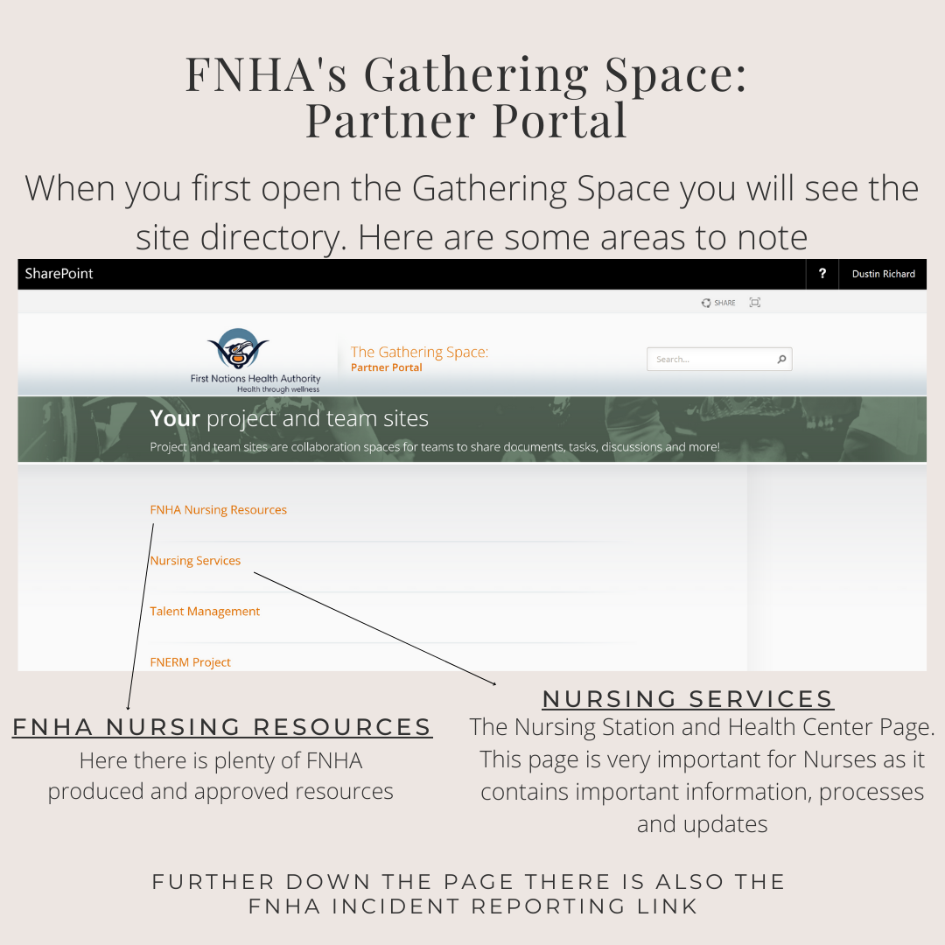

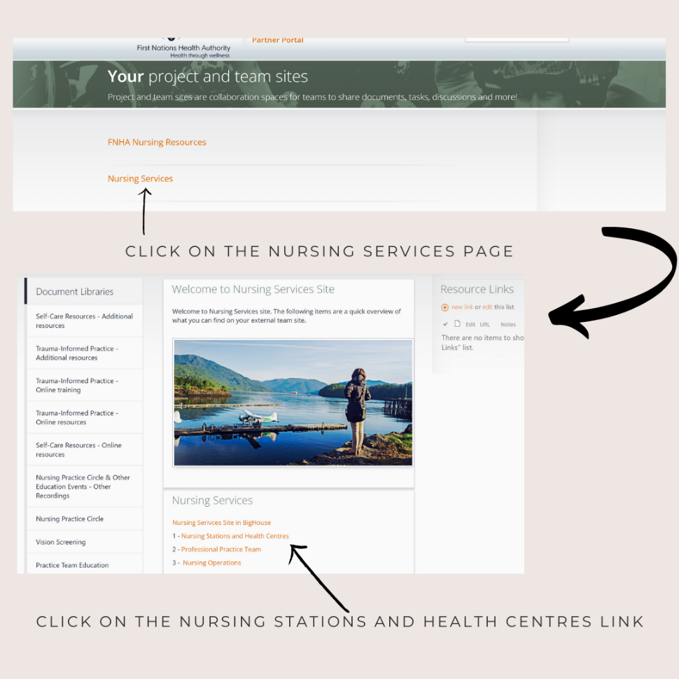

Understanding FNHA’s Gathering Space Continued

<https://partners.fnha.ca/sites/NS/NSHC/Default.aspx>

